0.1 Check Dataset Structure and Information

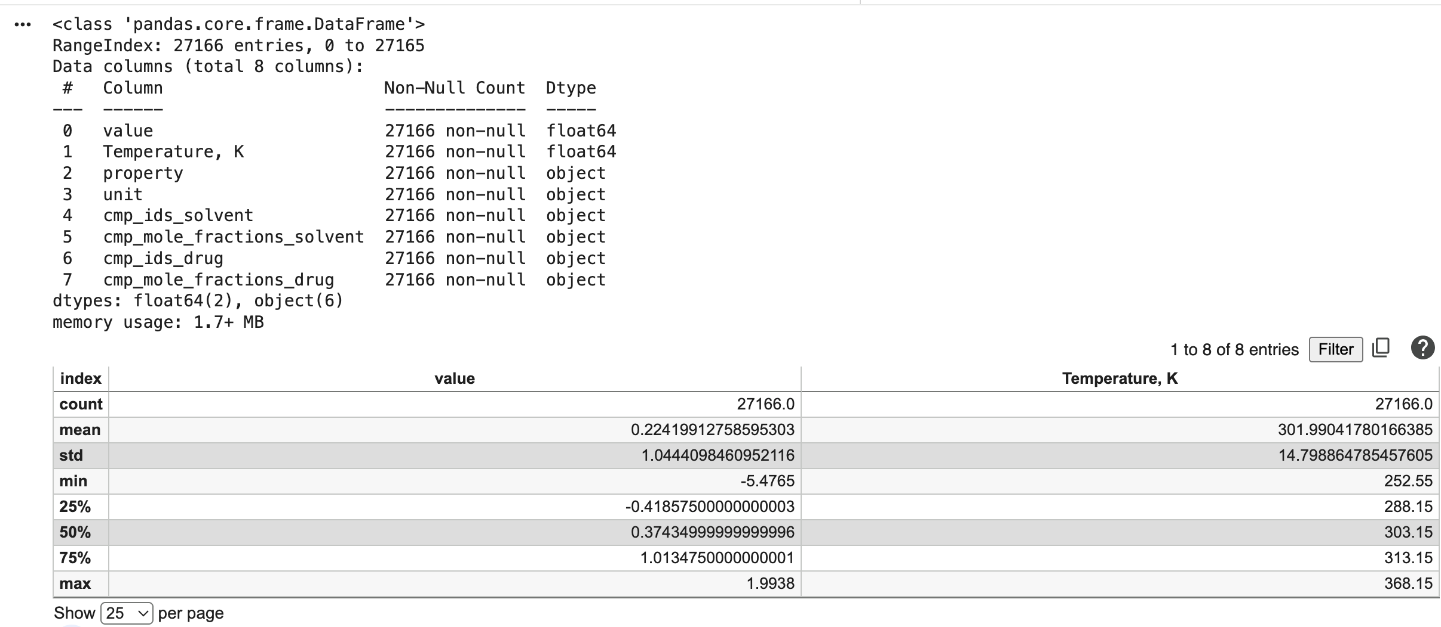
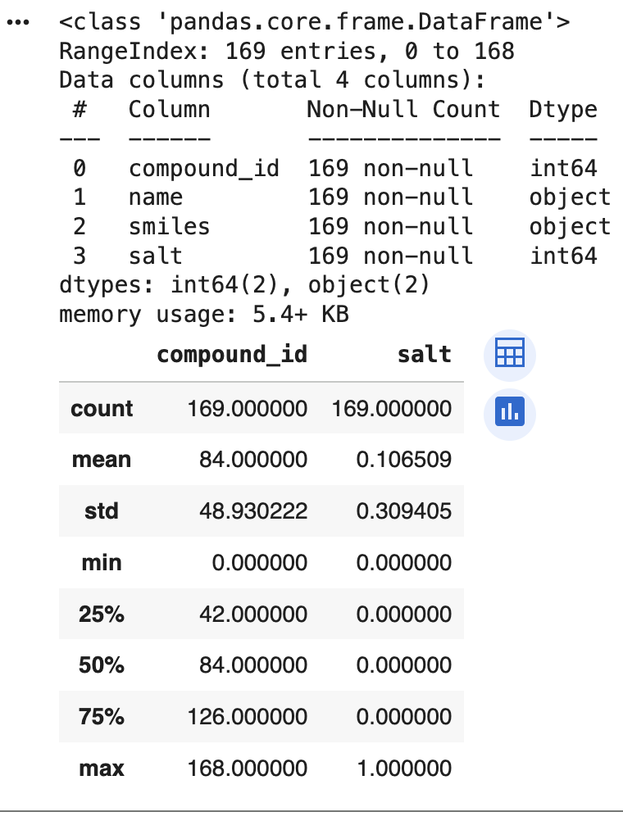

0.2 Check for Missing Data and Outliers in df and df_compound
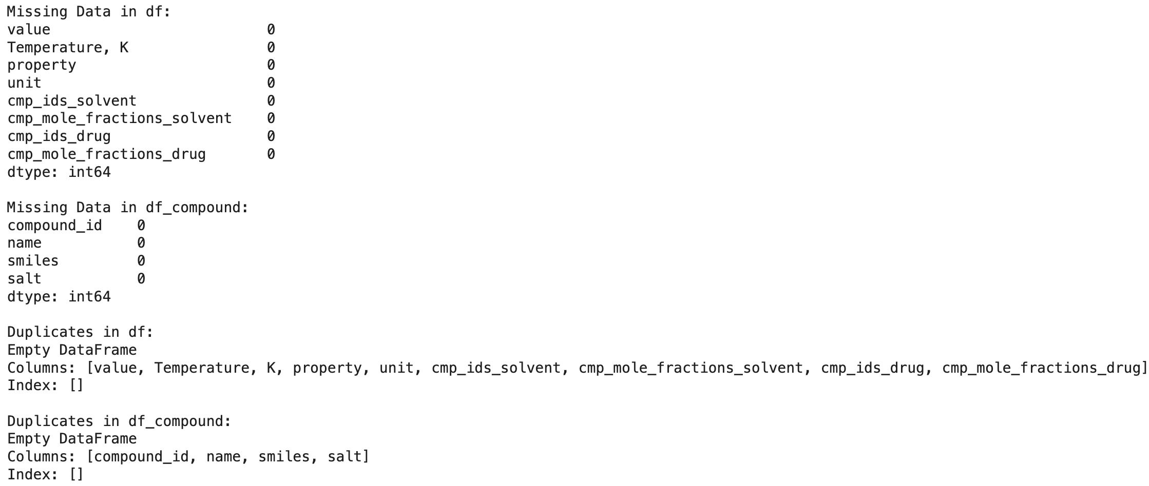
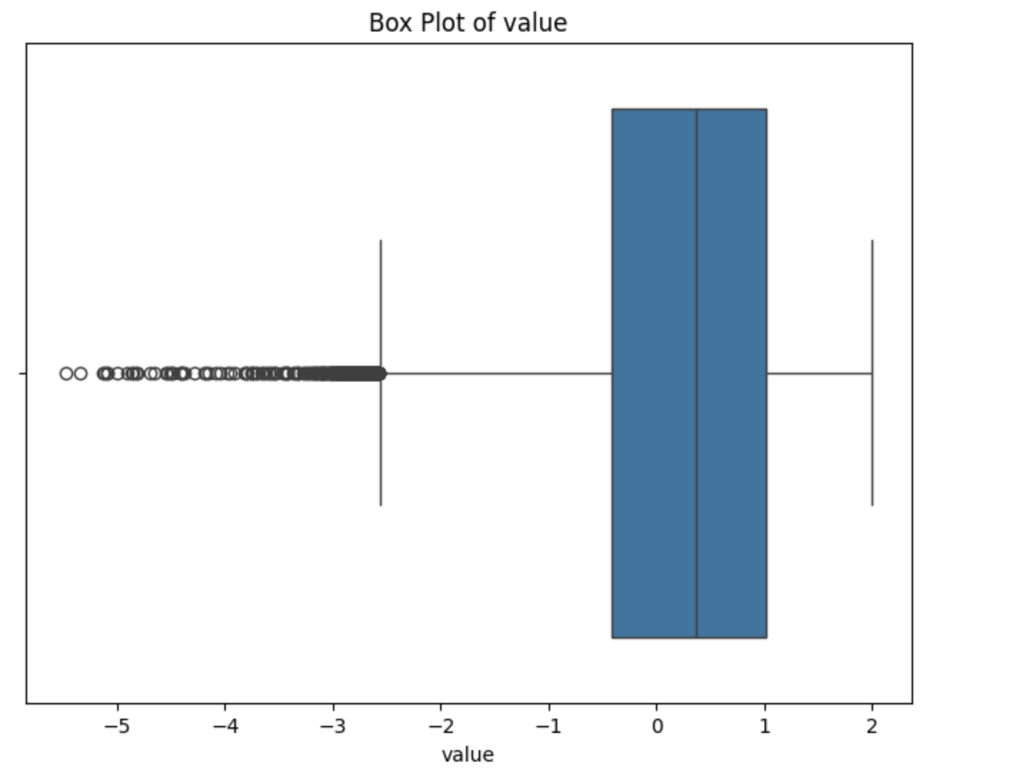
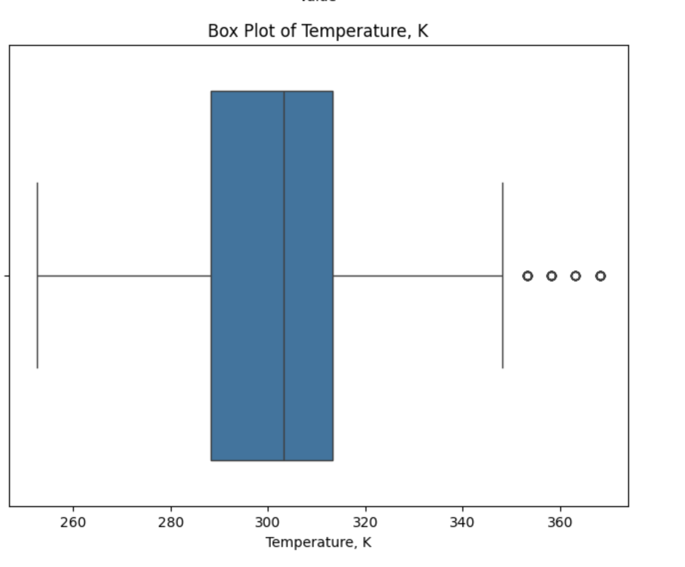

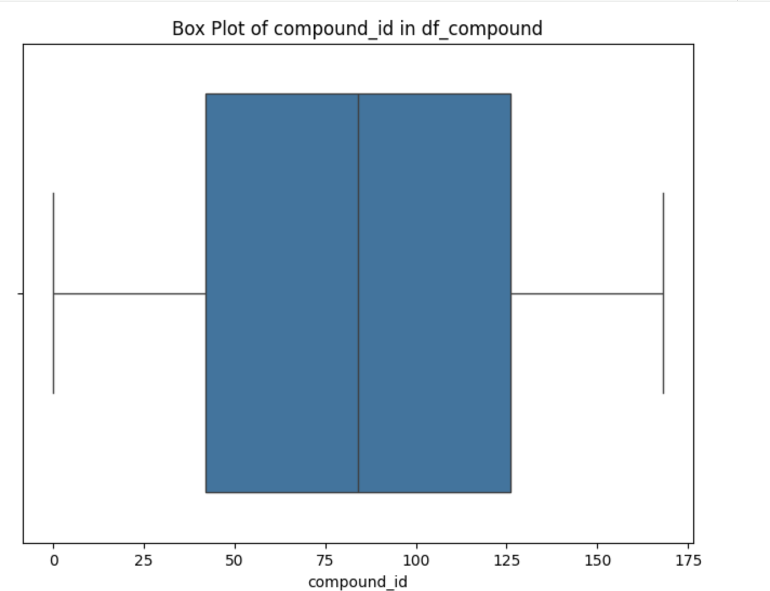
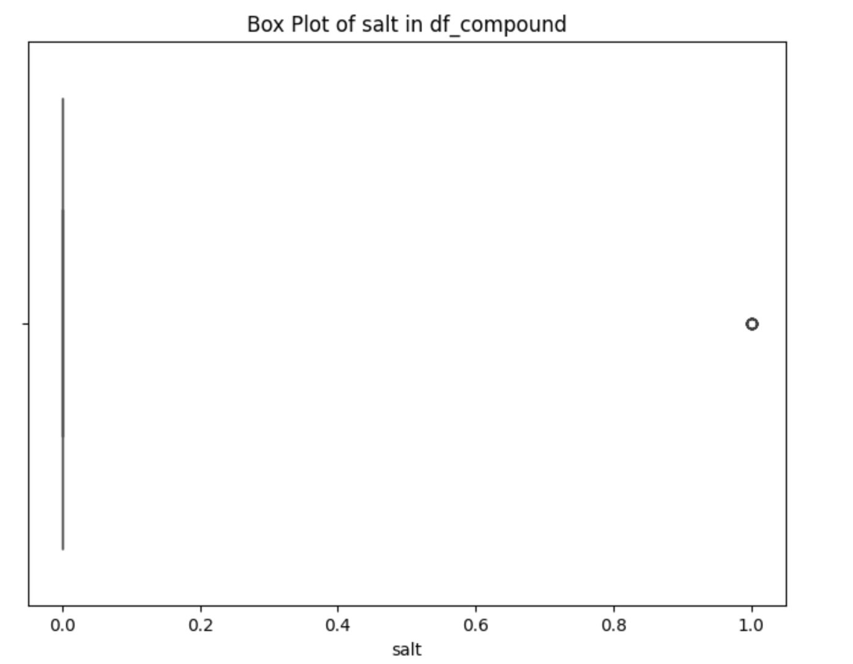

2.1 Check Feature Variances / Missing Data / Duplicates
[('drug_HBA', 'Not Applicable (Non-numeric)'),
('drug_HBD', 'Not Applicable (Non-numeric)'),
('drug_logP', 'Not Applicable (Non-numeric)'),
('drug_TPSA', 'Not Applicable (Non-numeric)'),
('drug_Dielectric', 0.05116844473282817),
('drug_δD', 0.037048165722233205),
('drug_δP', 0.008204438083816323),
('drug_δH', 0.6122883110168309),
('Solvent1_HBA', 'Not Applicable (Non-numeric)'),
('Solvent1_HBD', 'Not Applicable (Non-numeric)'),
('Solvent1_frac', 0.08845099271205835),
('Solvent1_logP', 'Not Applicable (Non-numeric)'),
('Solvent1_TPSA', 'Not Applicable (Non-numeric)'),
('Solvent1_Dielectric', 209.67126964213907),
('Solvent1_δD', 1.344129503269101),
('Solvent1_δP', 24.036071999535622),
('Solvent1_δH', 41.25729256241237),
('Solvent2_frac', 0.06811262949037754),
('Solvent2_HBA', 'Not Applicable (Non-numeric)'),
('Solvent2_HBD', 'Not Applicable (Non-numeric)'),
('Solvent2_logP', 'Not Applicable (Non-numeric)'),
('Solvent2_TPSA', 'Not Applicable (Non-numeric)'),
('Solvent2_Dielectric', 844.2780130648069),
('Solvent2_δD', 0.09479882845691663),
('Solvent2_δP', 24.018780530721155),
('Solvent2_δH', 172.09150793103686),
('Solvent1_Solvent2_Ra', 139.2580350595279),
('ILR_coordinate', 1.0291453485700837),
('weighted_HBA', 0.25644682686662196),
('weighted_HBD', 0.09851336913049018),
('weighted_logP', 0.29352749846825354),
('weighted_TPSA', 31.46447800853578),
('weighted_Dielectric', 634.9335914355269)]

features with small variances (1e-05):
[]

Missing Data in df_49:
value 0
Temperature, K 0
property 0
unit 0
cmp_ids_solvent 0
cmp_mole_fractions_solvent 0
cmp_ids_drug 0
cmp_mole_fractions_drug 0
Solvent1_id 0
Solvent1_frac 0
Solvent2_id 49
Solvent2_frac 49
Solvent1_name 0
Solvent2_name 49
drug_mol 0
Solvent1_smiles 0
Solvent2_smiles 49
Solvent1_mol 0
Solvent2_mol 49
drug_HBA 0
drug_HBD 0
drug_logP 0
drug_TPSA 0
Solvent1_HBA 0
Solvent1_HBD 0
Solvent1_logP 0
Solvent1_TPSA 0
Solvent2_HBA 49
Solvent2_HBD 49
Solvent2_logP 49
Solvent2_TPSA 49
Solvent1_Dielectric 0
Solvent1_δD 0
Solvent1_δP 0
Solvent1_δH 0
Solvent2_Dielectric 49
Solvent2_δD 49
Solvent2_δP 49
Solvent2_δH 49
drug_δD 0
drug_δP 0
drug_δH 0
Solvent1_Solvent2_Ra 49
drug_Dielectric 0
drug_fp 0
Solvent1_fp 0
Solvent2_fp 49
ILR_coordinate 49
weighted_HBA 0
weighted_HBD 0
weighted_logP 0
weighted_TPSA 0
weighted_Dielectric 0
weighted_fp 0
dtype: int64

Duplicates in df_49:
Empty DataFrame
Columns: [value, Temperature, K, property, unit, cmp_ids_solvent, cmp_mole_fractions_solvent, cmp_ids_drug, cmp_mole_fractions_drug, Solvent1_id, Solvent1_frac, Solvent2_id, Solvent2_frac, Solvent1_name, Solvent2_name, drug_mol, Solvent1_smiles, Solvent2_smiles, Solvent1_mol, Solvent2_mol, drug_HBA, drug_HBD, drug_logP, drug_TPSA, Solvent1_HBA, Solvent1_HBD, Solvent1_logP, Solvent1_TPSA, Solvent2_HBA, Solvent2_HBD, Solvent2_logP, Solvent2_TPSA, Solvent1_Dielectric, Solvent1_δD, Solvent1_δP, Solvent1_δH, Solvent2_Dielectric, Solvent2_δD, Solvent2_δP, Solvent2_δH, drug_δD, drug_δP, drug_δH, Solvent1_Solvent2_Ra, drug_Dielectric, drug_fp, Solvent1_fp, Solvent2_fp, ILR_coordinate, weighted_HBA, weighted_HBD, weighted_logP, weighted_TPSA, weighted_Dielectric, weighted_fp]
Index: []

[0 rows x 54 columns]

2.2 Correlation Analysis Between Features and Target
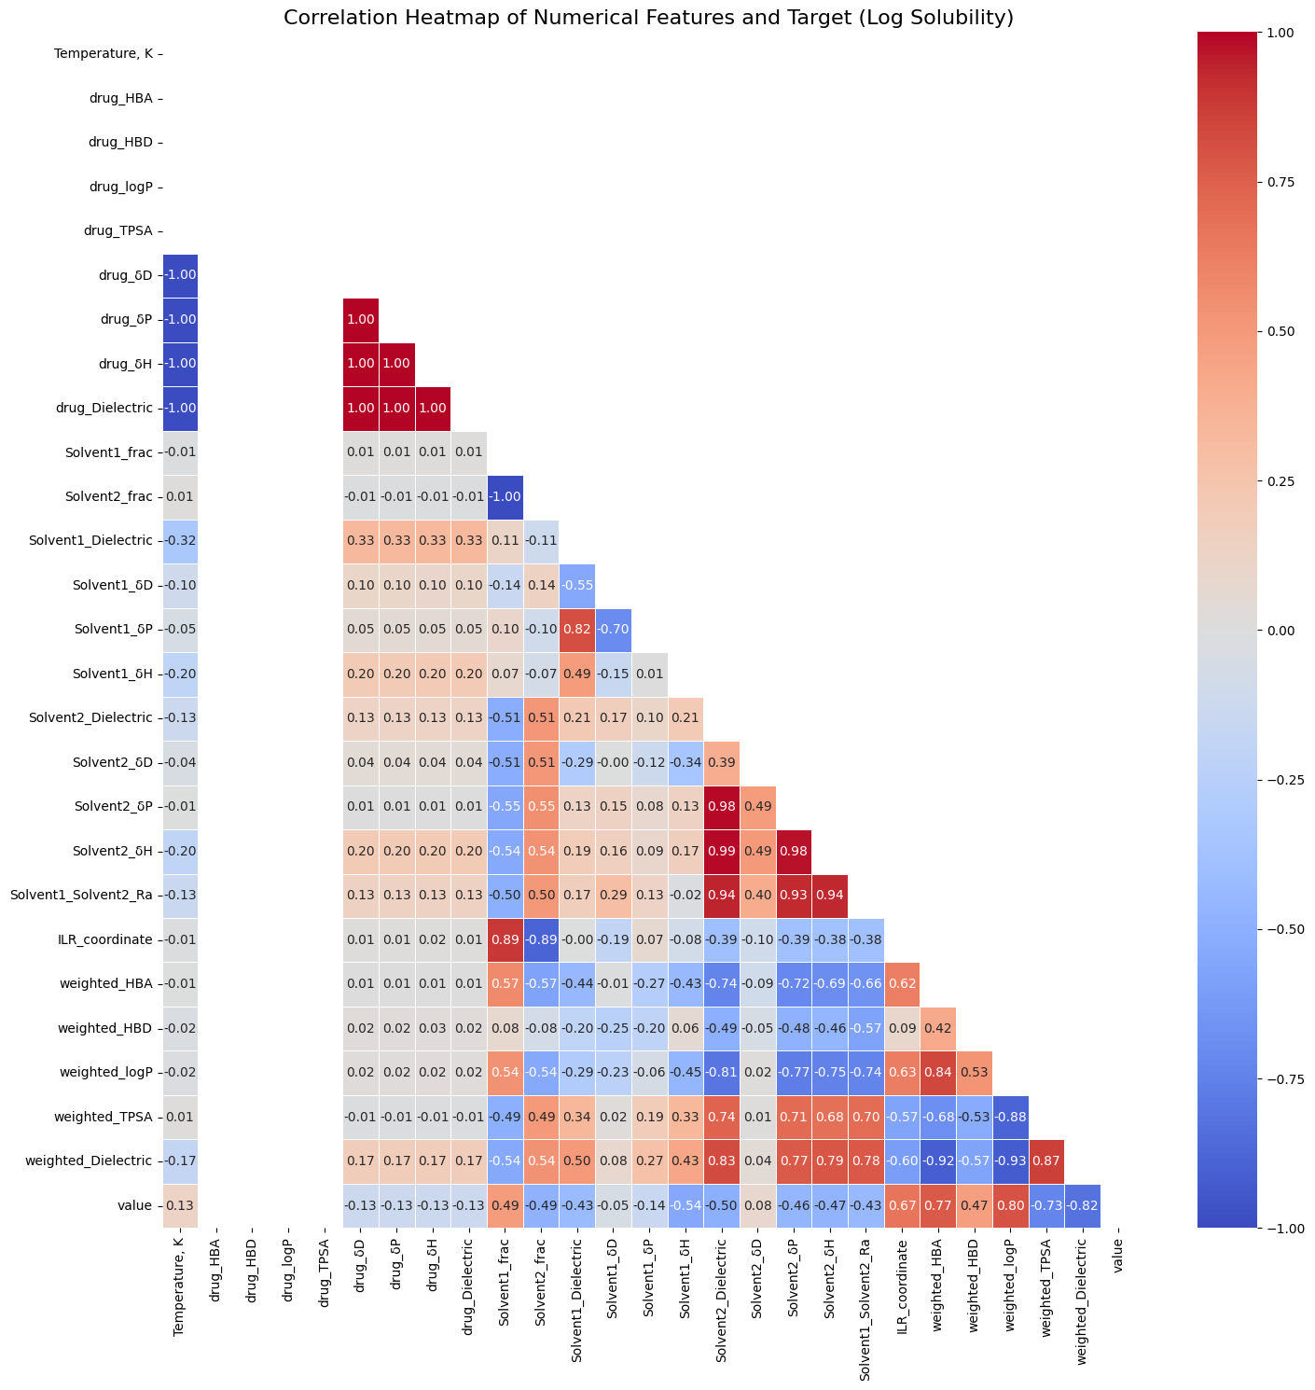

Correlation with Target Variable ('value'):
value 1.000000
weighted_logP 0.800675
weighted_HBA 0.767912
ILR_coordinate 0.669573
Solvent1_frac 0.488742
weighted_HBD 0.469875
Temperature, K 0.126170
Solvent2_δD 0.081065
Solvent1_δD -0.047065
drug_δH -0.125937
drug_Dielectric -0.126144
drug_δD -0.126151
drug_δP -0.126151
Solvent1_δP -0.141411
Solvent1_Dielectric -0.425882
Solvent1_Solvent2_Ra -0.433548
Solvent2_δP -0.455894
Solvent2_δH -0.470666
Solvent2_frac -0.488742
Solvent2_Dielectric -0.504084
Solvent1_δH -0.543192
weighted_TPSA -0.730849
weighted_Dielectric -0.822935
drug_HBA NaN
drug_HBD NaN
drug_logP NaN
drug_TPSA NaN
Name: value, dtype: float64

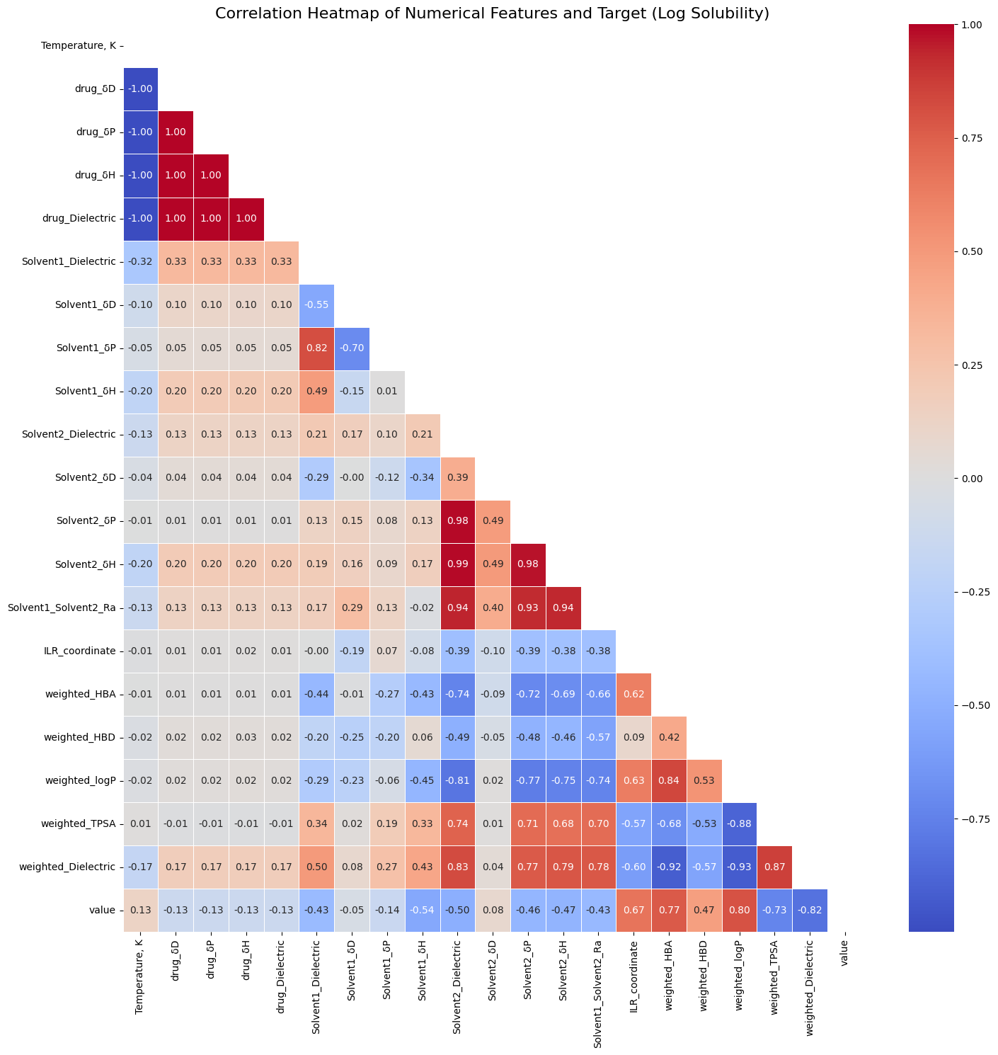

Correlation with Target Variable ('value'):
value 1.000000
weighted_logP 0.800675
weighted_HBA 0.767912
ILR_coordinate 0.669573
weighted_HBD 0.469875
Temperature, K 0.126170
Solvent2_δD 0.081065
Solvent1_δD -0.047065
drug_δH -0.125937
drug_Dielectric -0.126144
drug_δD -0.126151
drug_δP -0.126151
Solvent1_δP -0.141411
Solvent1_Dielectric -0.425882
Solvent1_Solvent2_Ra -0.433548
Solvent2_δP -0.455894
Solvent2_δH -0.470666
Solvent2_Dielectric -0.504084
Solvent1_δH -0.543192
weighted_TPSA -0.730849
weighted_Dielectric -0.822935
Name: value, dtype: float64

2.3 Univariate Analysis - Flutamide Log Solubility and Temperature Distribution

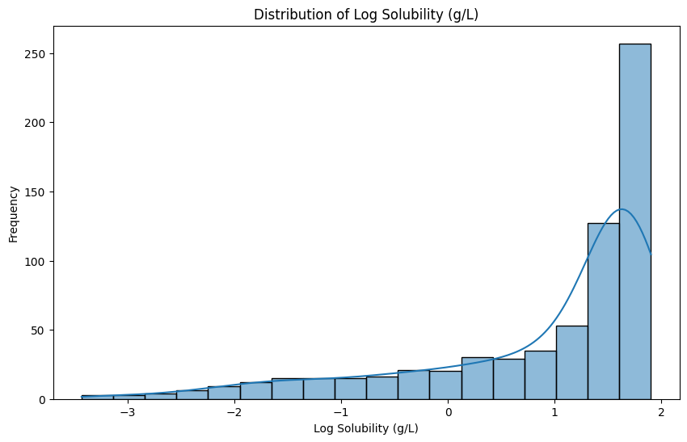

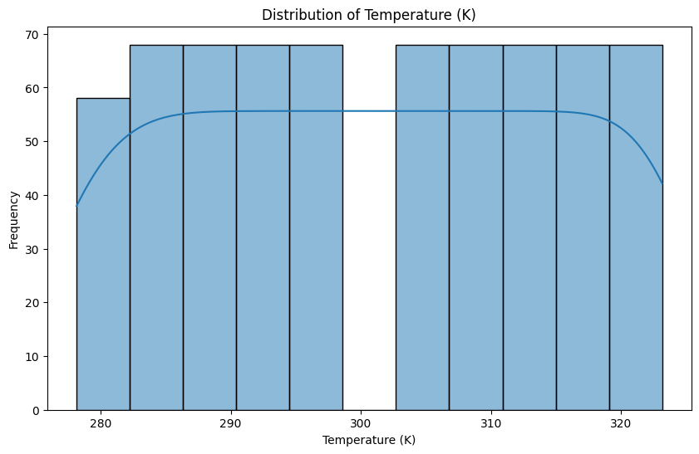

Number of Solubility Data Points Per Solvent Combination
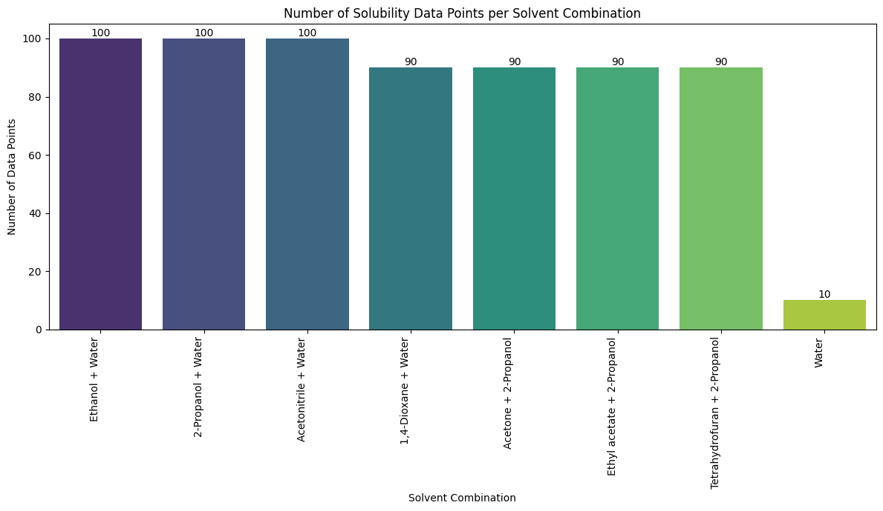

2.4 Univariate Analysis - Distribution of Solvent 1 and 2 Mole Fractions
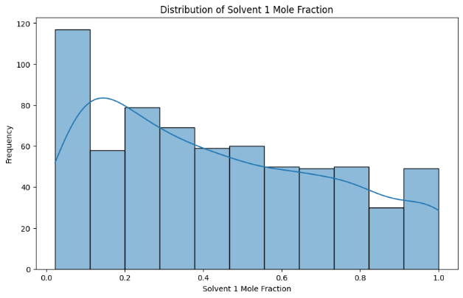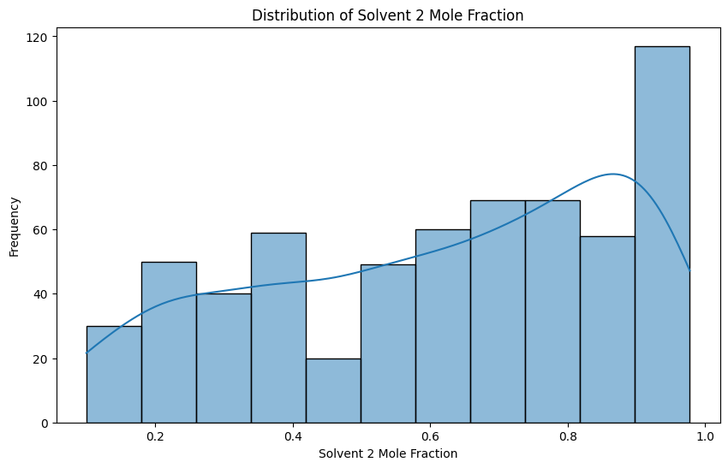

2.5 Bivariate Analysis - Distribution of Flutamide Log Solubility by Temperature Range (Percentage) for Flutamide and Solvents
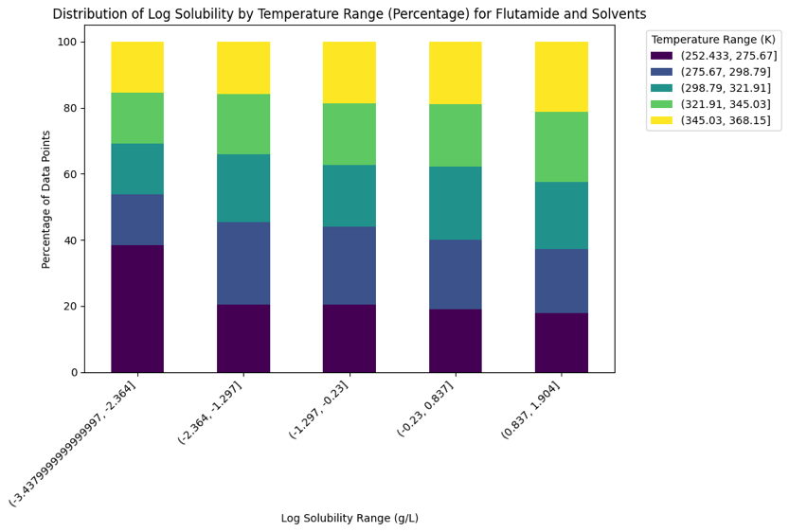

2.6 Bivariate Analysis - Flutamide Log Solubility VS Solvent 1 Mole Fractoins in Different Temperature Ranges
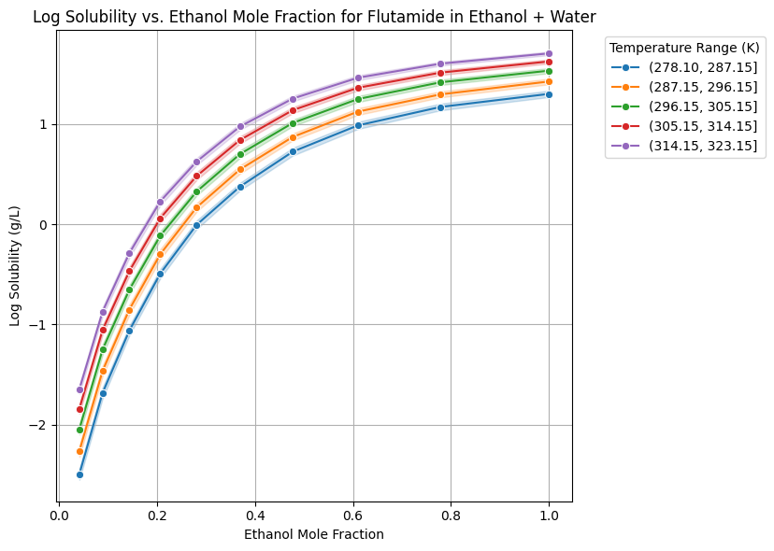
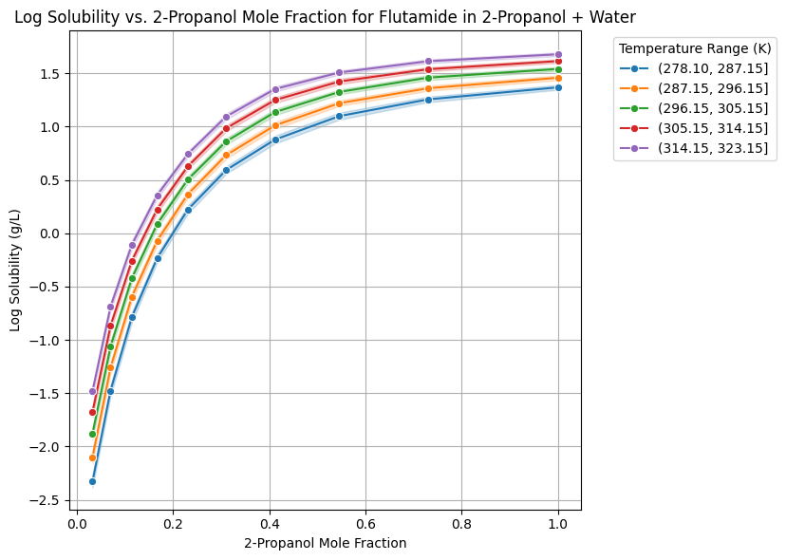

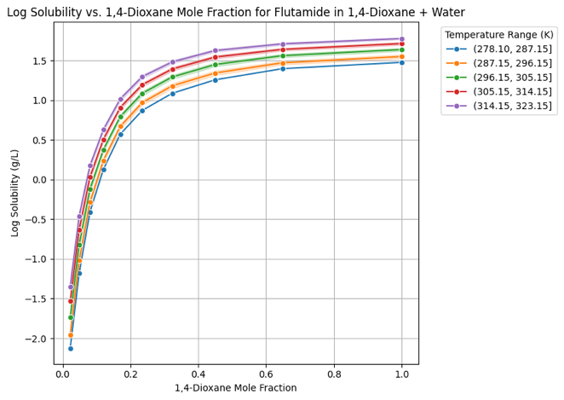
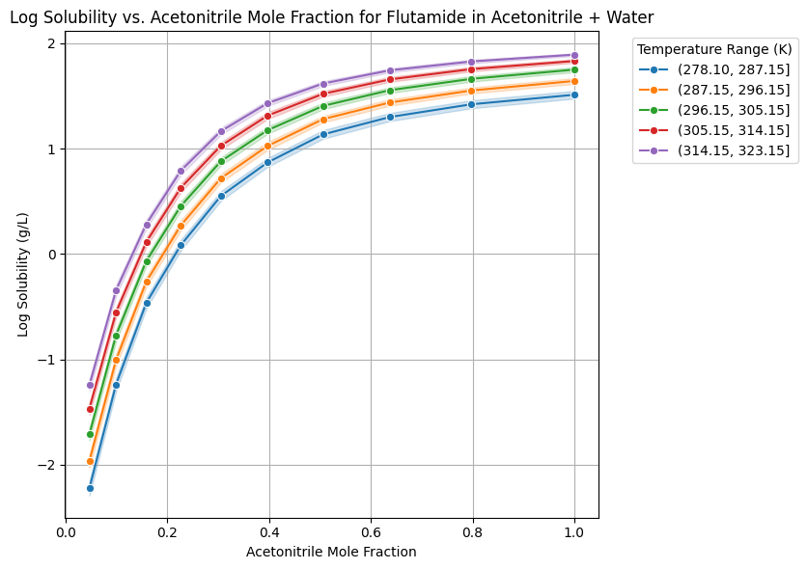

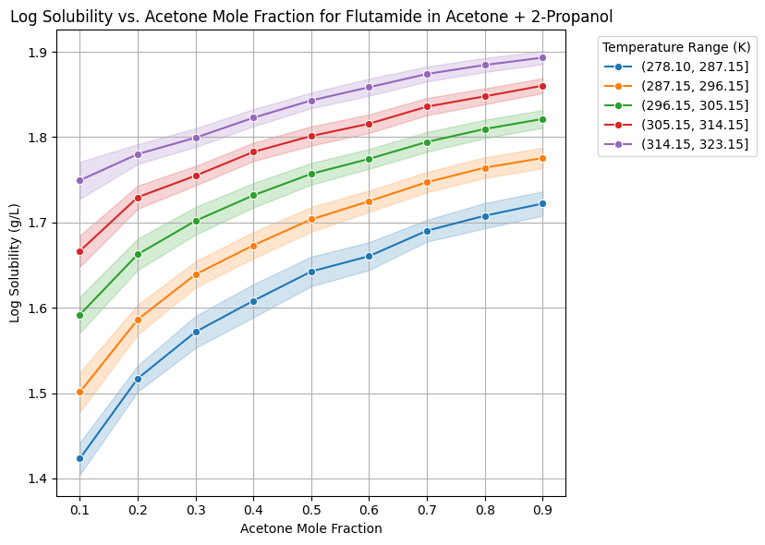

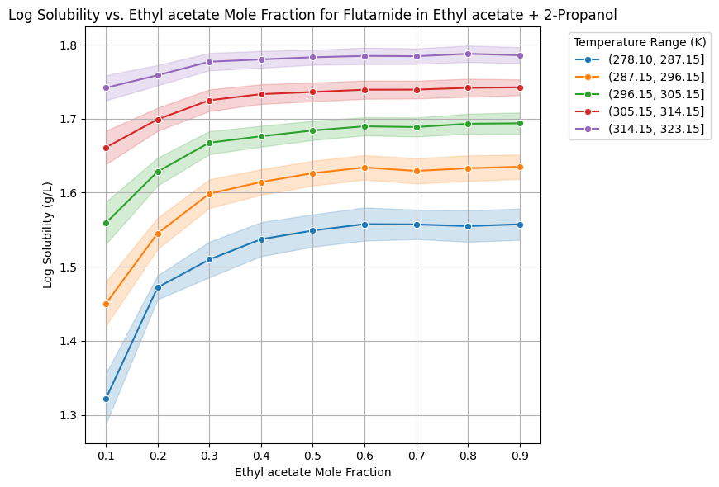
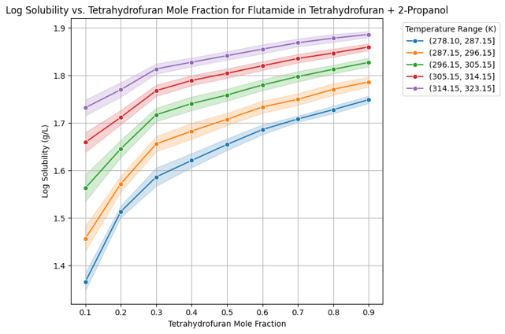

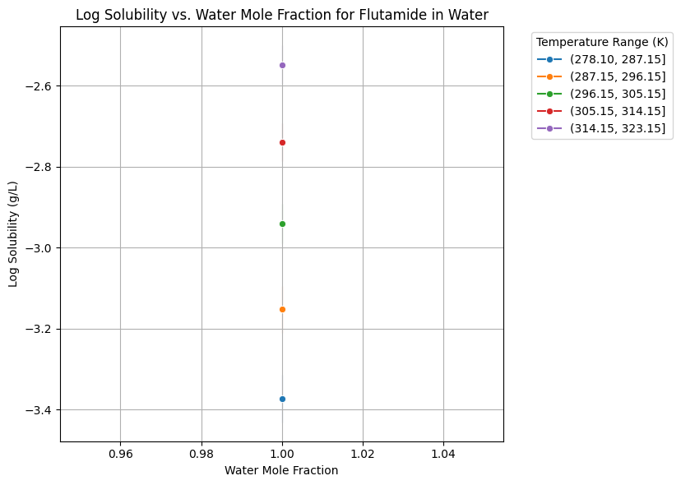

2.7 Bivariate Analysis - Flutamide Log Solubility VS Solvent 2 Mole Fractoins in Different Temperature Ranges

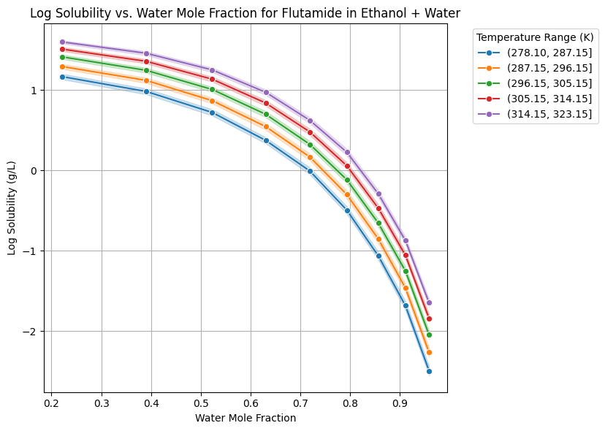
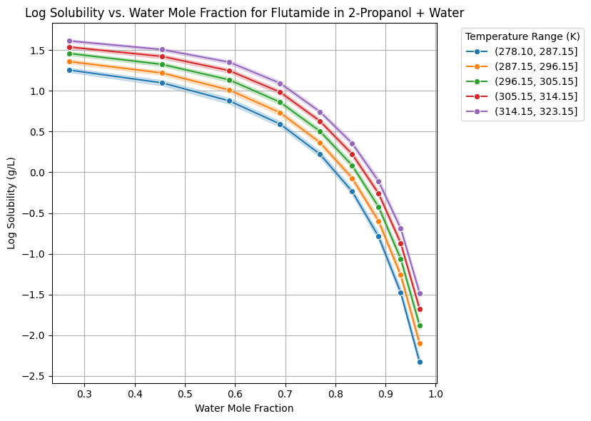

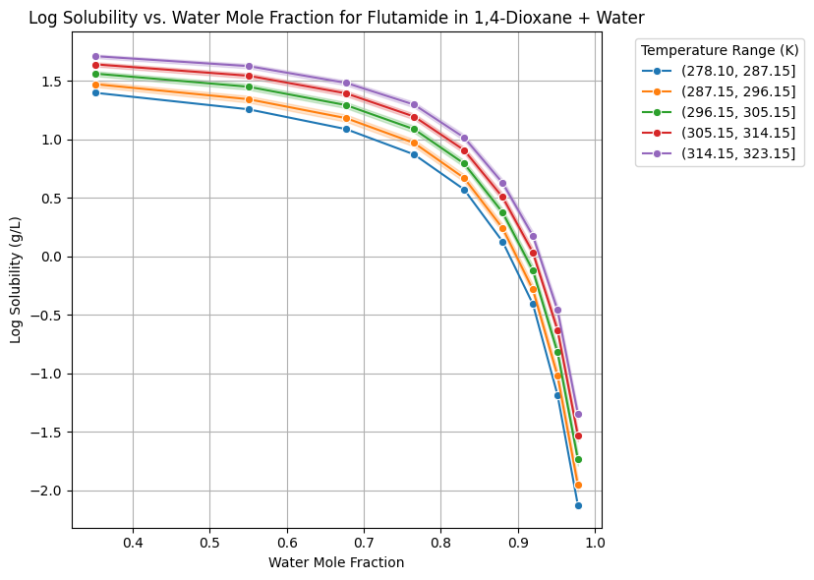

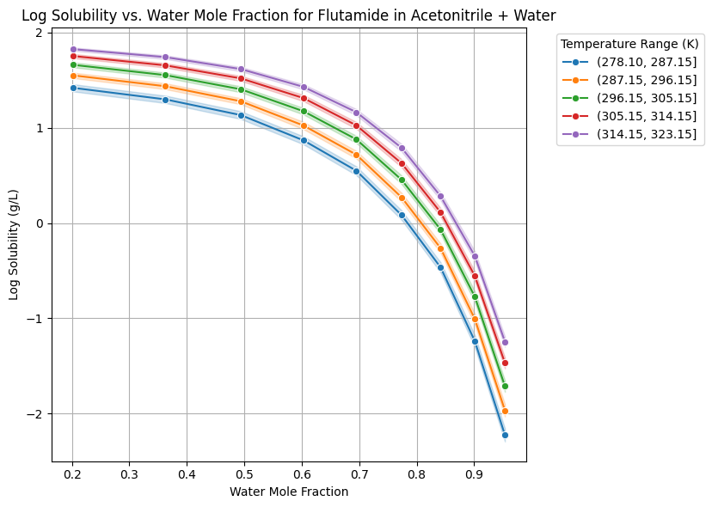
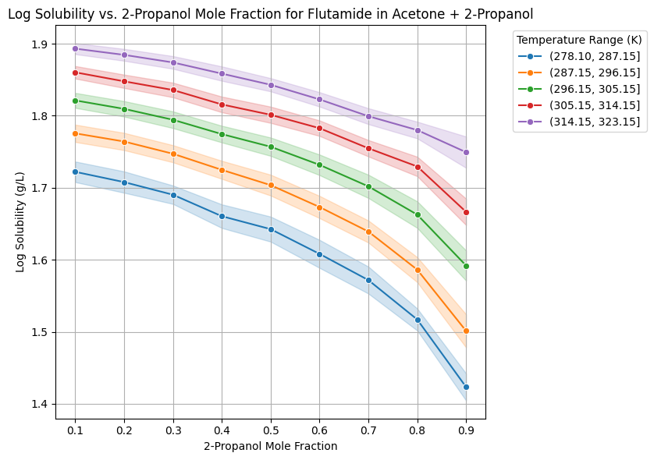

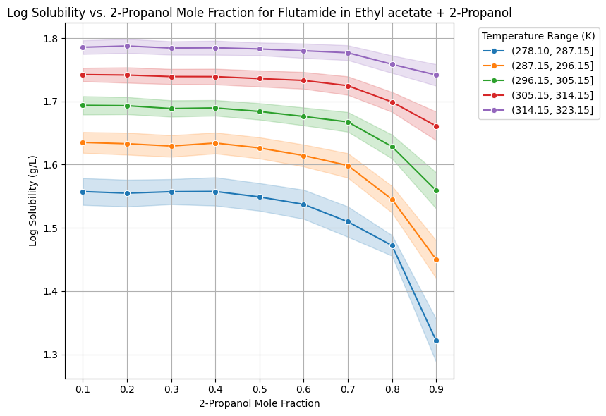

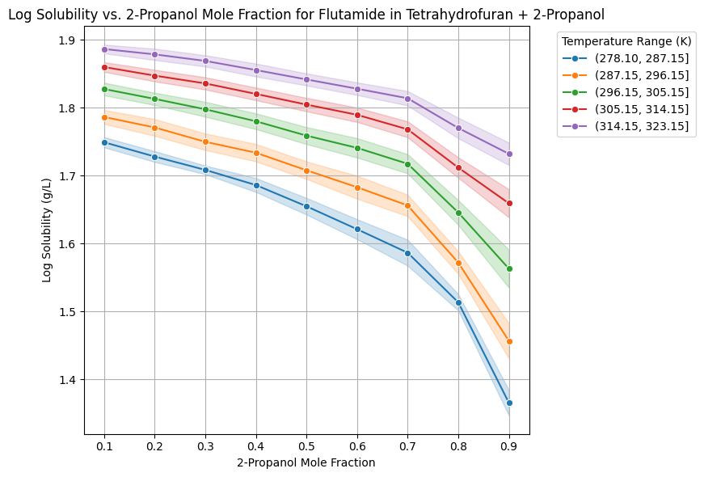

2.8 Bivariate Analysis - Flutamide Log Solubility VS Temperature for Different Solvent Combination
